1、configuration

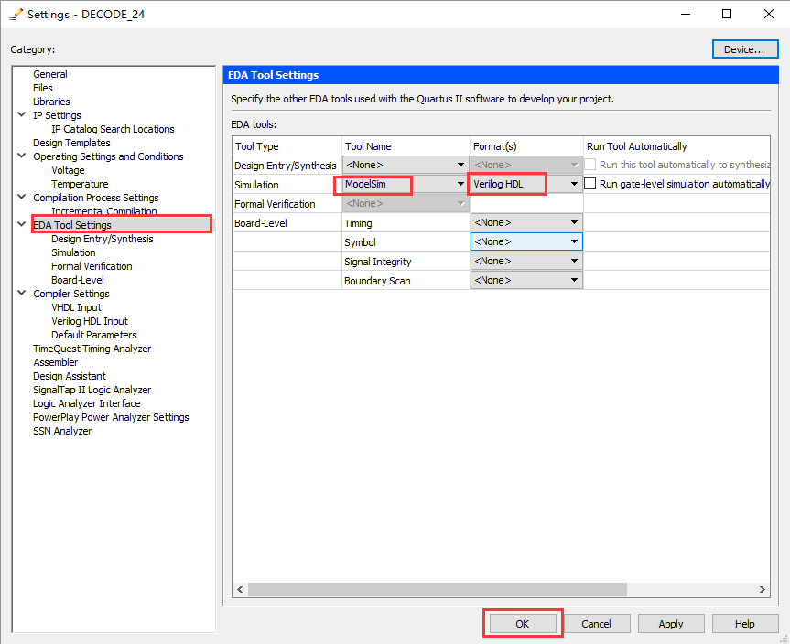

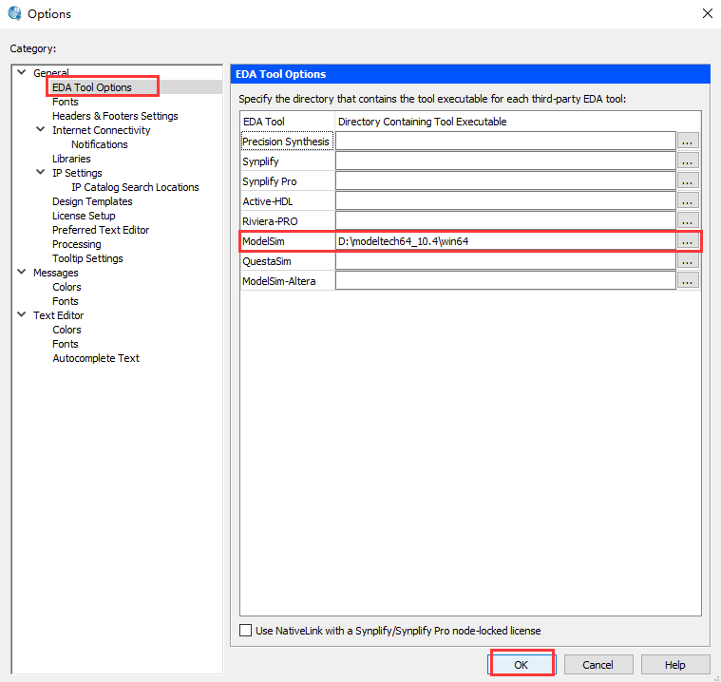

http://www.cnblogs.com/emouse/archive/2012/07/08/2581223.html

http://www.cnblogs.com/Jezze/archive/2012/09/14/2684333.html

2、生成testbench writer文件

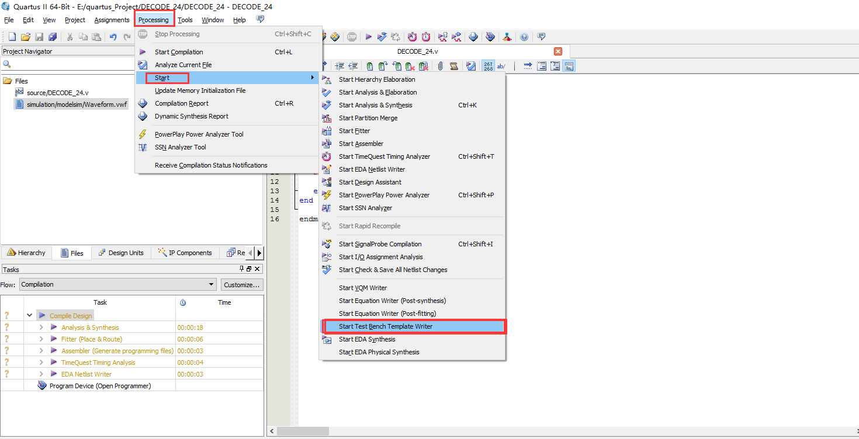

Then we can see a file:

simulation->modesim->\*\*\*.vt

3、编写testbench文件

4、仿真步骤

